FACE MASK DETECTION

Artificial Intelligence

Project Proposal 2021

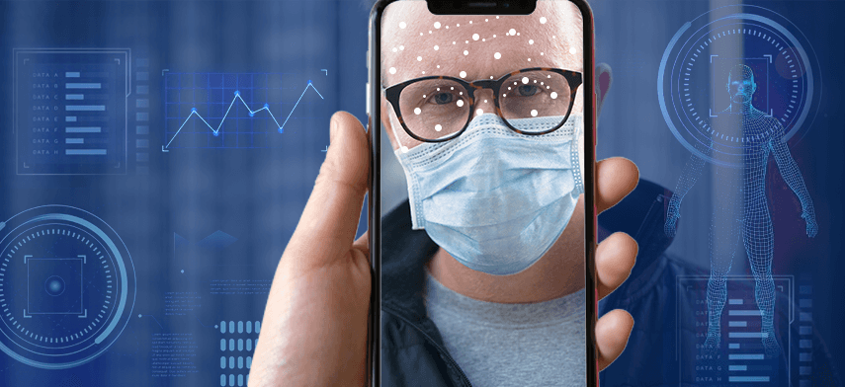

Group Members: Class ID: 106266

Sahil Nenwani 9870

Hassan Noor 9827

GitHub Picture

